The correct body position for measuring blood pressure

Upper arm (brachial artery) blood pressure measurement is the standard and most accurate site for clinical blood pressure assessment.
Ref.
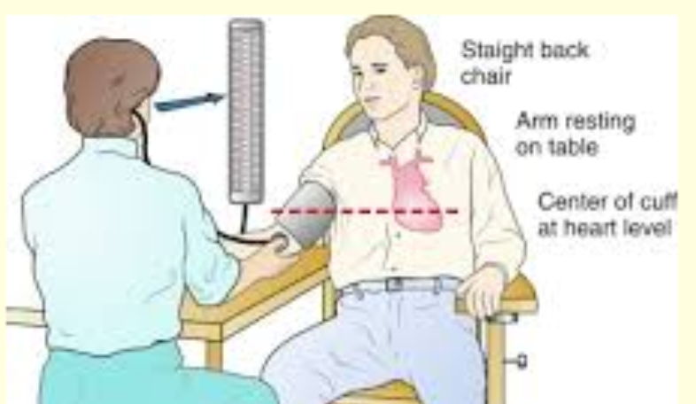

Real Patient Case: How position and setting changed consecutive BP readings:

